**Team 13: Java Swing app, Android and iOS app for IHO department**

Sponsor: Dr. Timothy Lindquist

Jaiswal, Arpit; Bhatt, Mihir; Nayak, Gowtham; Singhal, Sweta; Senathamil, Sindhu

**First Demo or Prototype | Screenshots**

**Update on Java Swing App:** We have successfully created the UI and will continue to enhance the aesthetics in future sprints. We are able to generate JSON form Java Swing app and push it to the server.

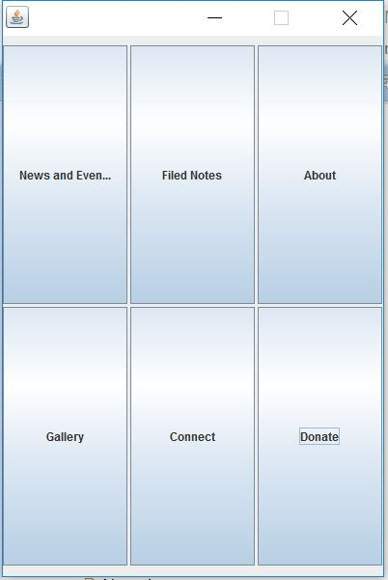

Figure 1: Main Page of the Java Swing Application

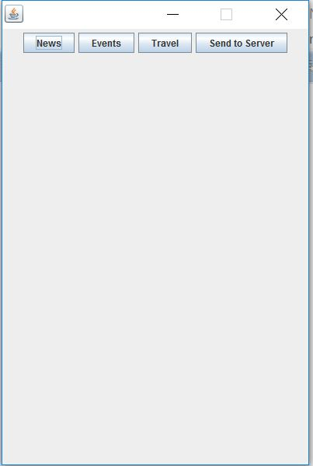

Figure 2: News, Events and Travel Menu Page

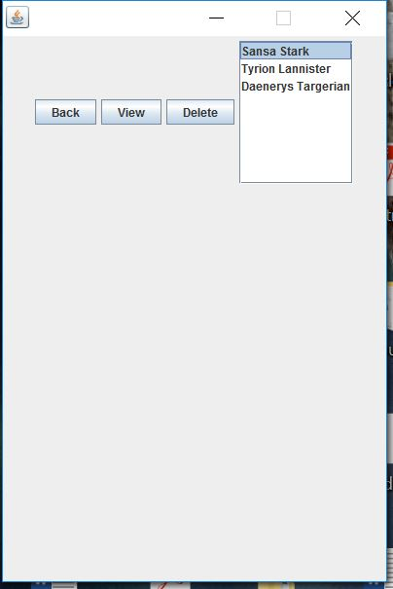

Figure 3: News List with View, Delete button

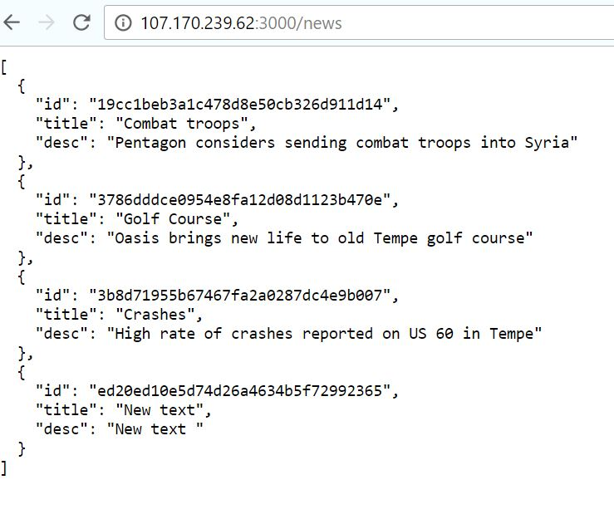

Figure 4: Server before updating the news content

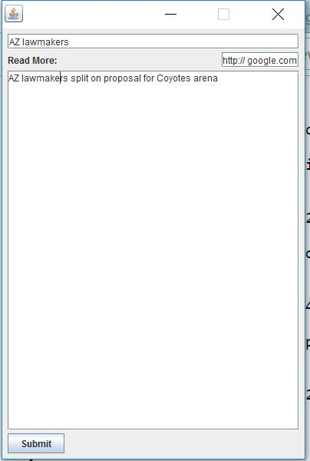

Figure 5: Adding news content

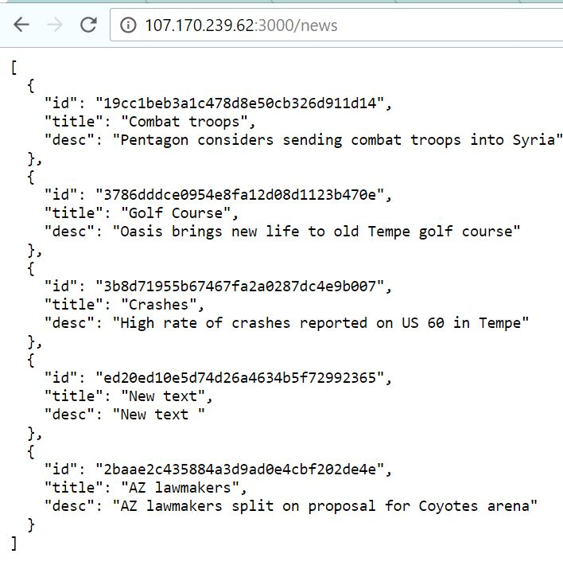

Figure 6: Server after updating the news content

**Update on iOS app:** We are creating the app from scratch in SWIFT 3. We have successfully created parts of Home page, About, Donate, News+Events UI. We are able to connect to the server and show the latest list of news which was updated in the swing app.

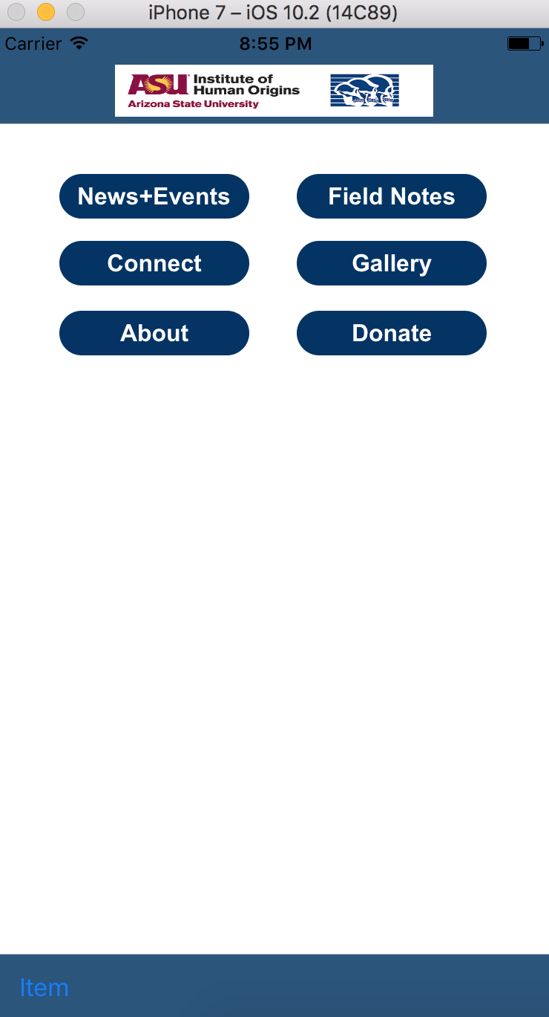

*Figure 7: Home Page of IHO app in iOS*

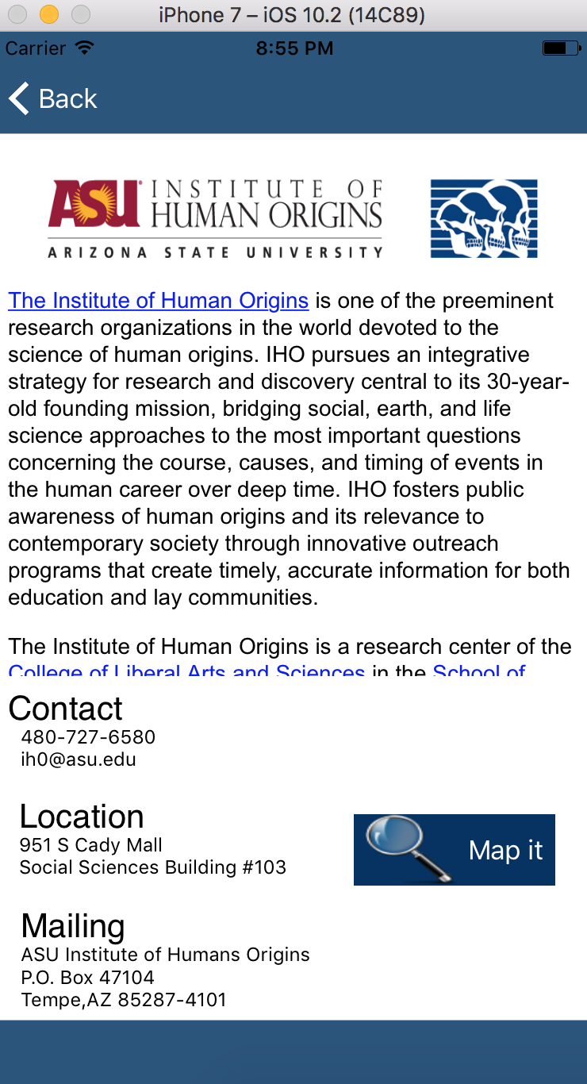

*Figure 8: About Page of IHO app in iOS. Implemented Table view, web view integrated google maps.*

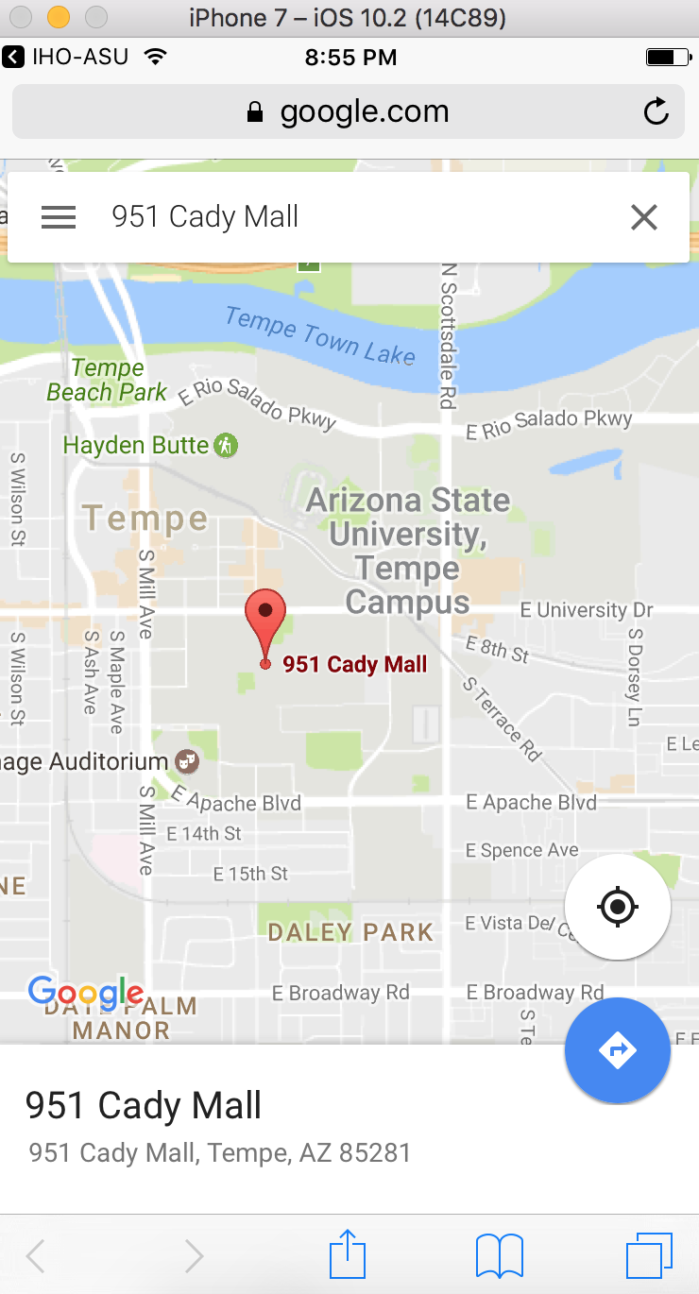

*Figure 9: When you click on maps in about page of IHO app in iOS we can see the location of IHO department on google maps.*

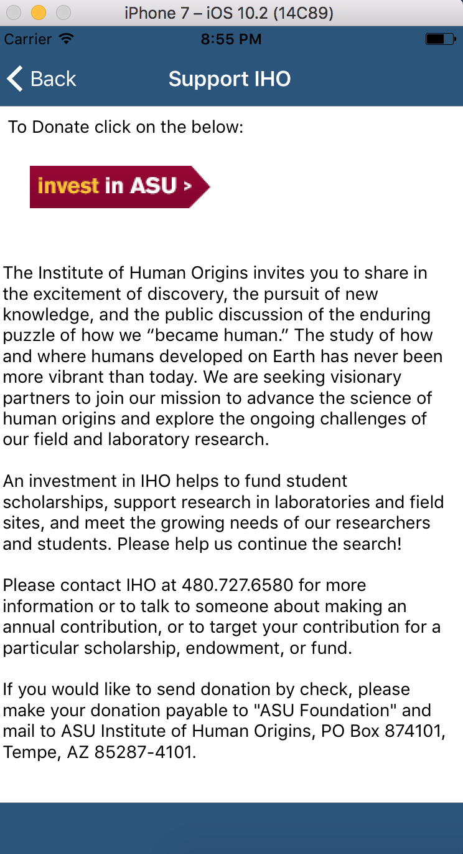

*Figure 10: Donate Page of IHO app in iOS where we have a lnk to donate and clicking on that lnk would lead us to IHO Donate website.*

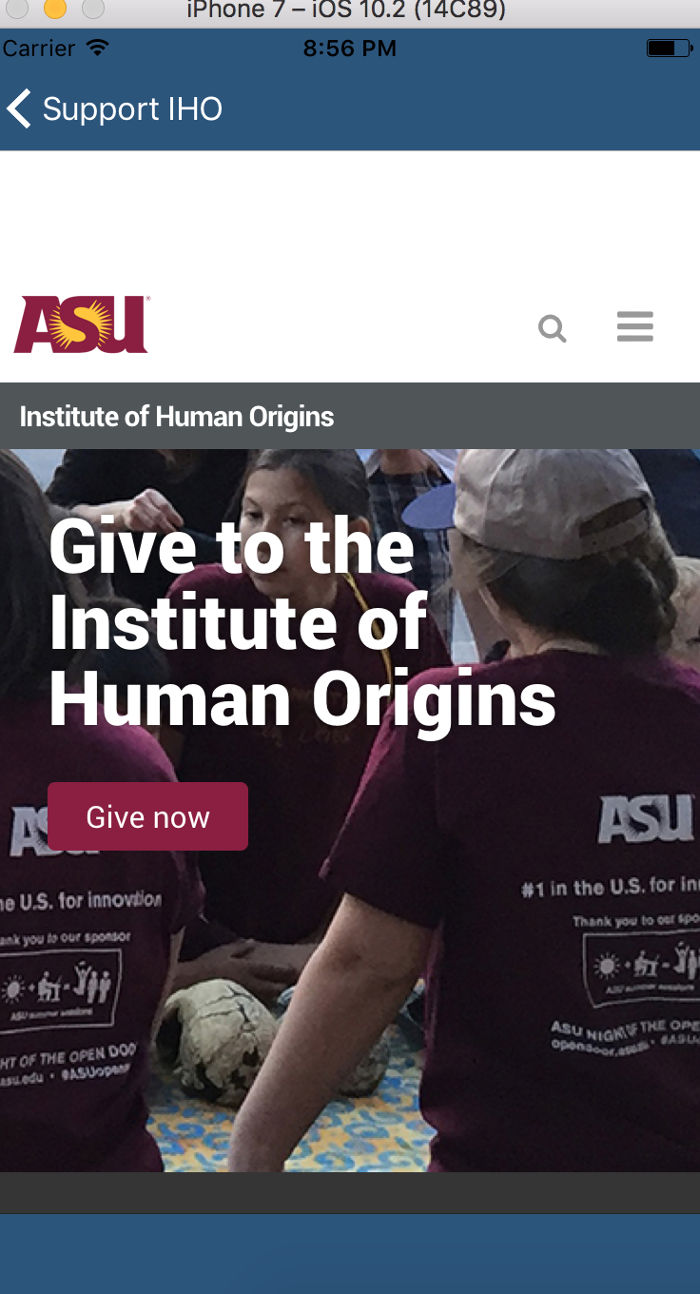

*Figure 11: This page is opened in IHO app in iOS when we click on the invest in IHO link on Donate page.*

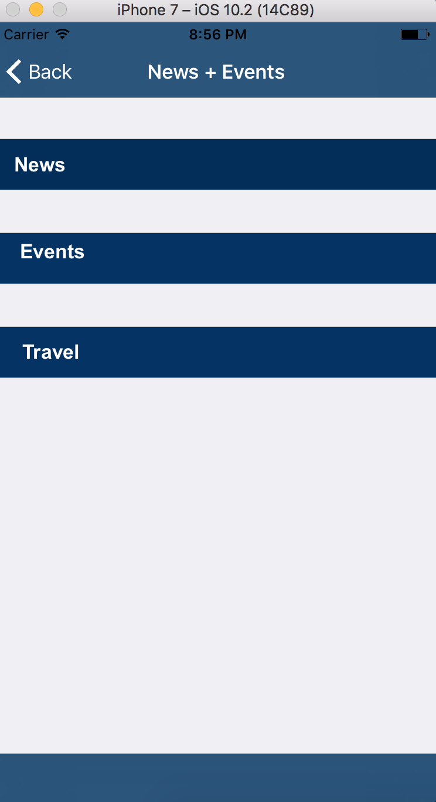

*Figure 12: News+Events Page of IHO app in iOS. We created a static Table view for this in swift 3.*

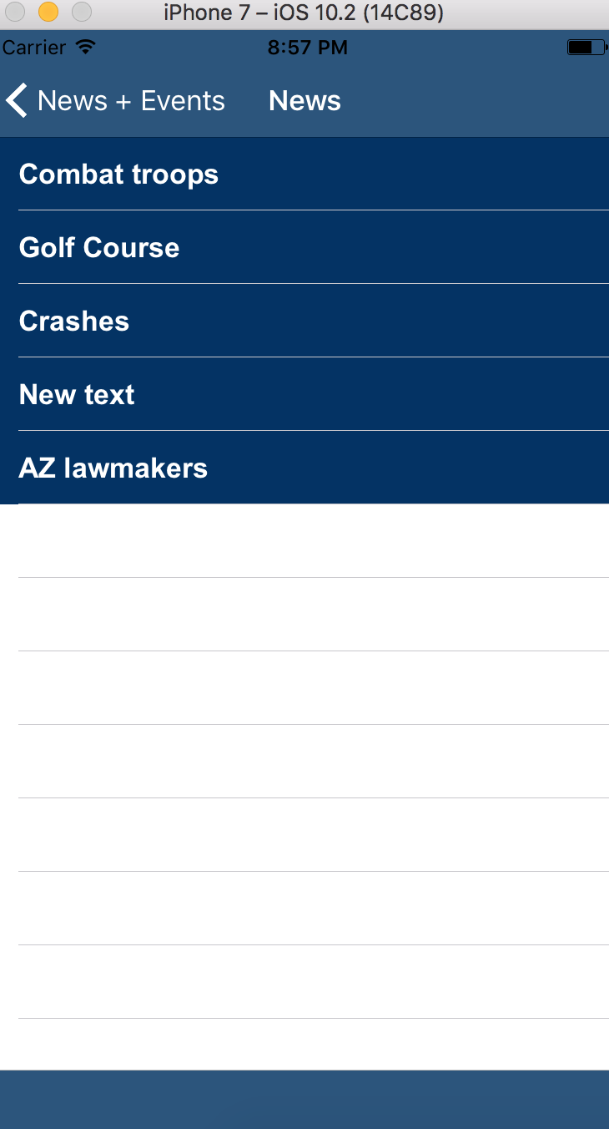

*Figure 13: When we click on news the json from server is fetched and the latest ost of news which have been modified by the IHO admin is displayed in the form of list.*

**Update on Android app:** We have successfully resolved the database exception. We are able to connect to the server and show the latest list of news which was updated in the swing app.

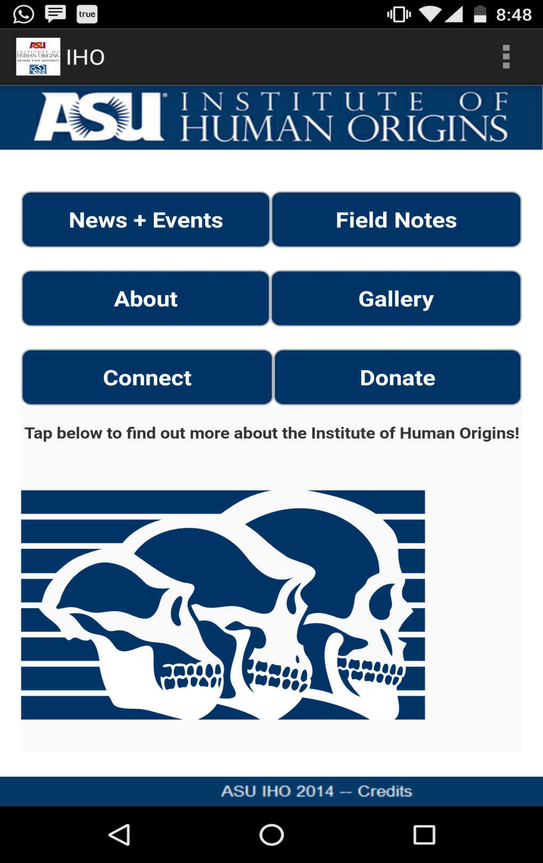

*Figure 14: This is application’s home page. The user can click any of the 6 buttons (New + Events, Field Notes, About, Gallery, Connect, Donate) to know corresponding information.*

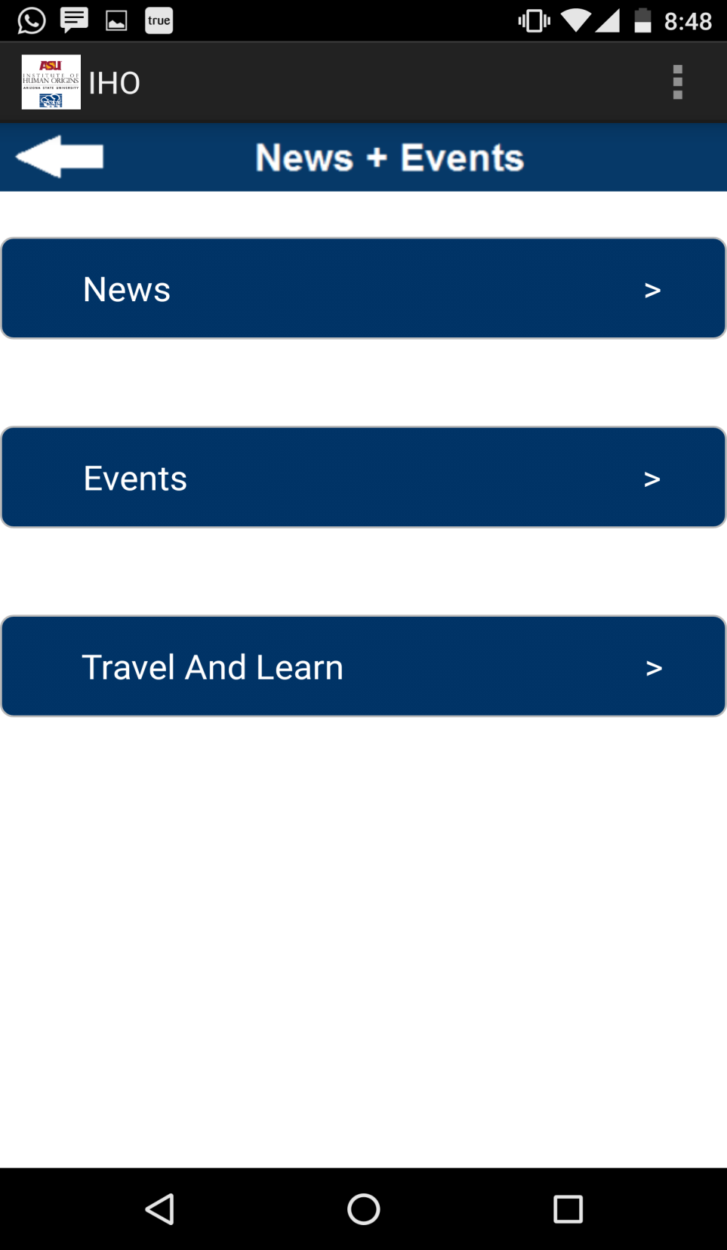

*Figure 15:The user is navigated to the above screen if he clicks on News + Events button from Home Page. Here, the user has options to view News, Events and Travel & Learn Information.*

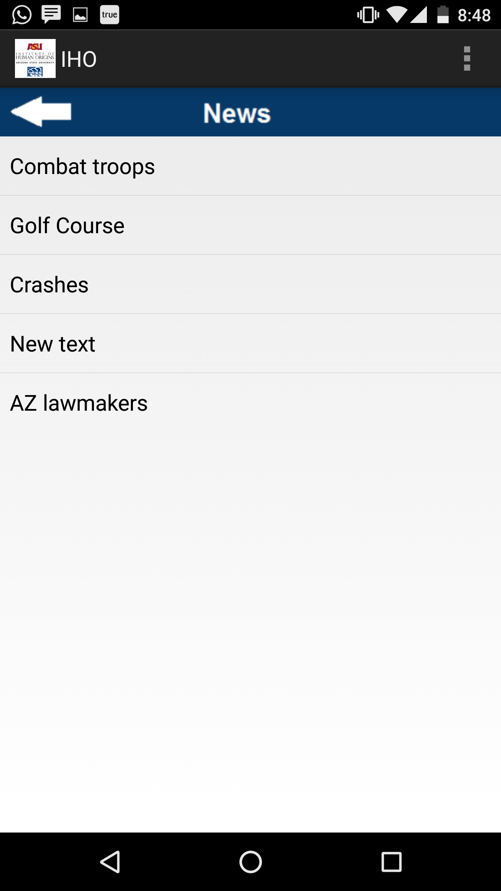

*Figure 16:On clicking “News” in the previous screen, fetches updated News List from the IHO Server, updates the local database and displays like above. User can now click on any of the “News” to know more about that. Prior to this project implementation, this section did not come up due to Database Exceptions and used to show static news from local database.*

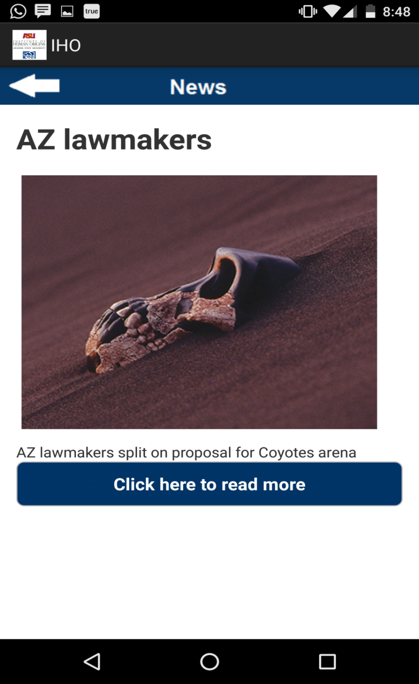

*Figure 17:On selecting particular News from the News List, opens up this screen to show detailed News Information. This screen show the updated information, fetched directly from the IHO Server.*

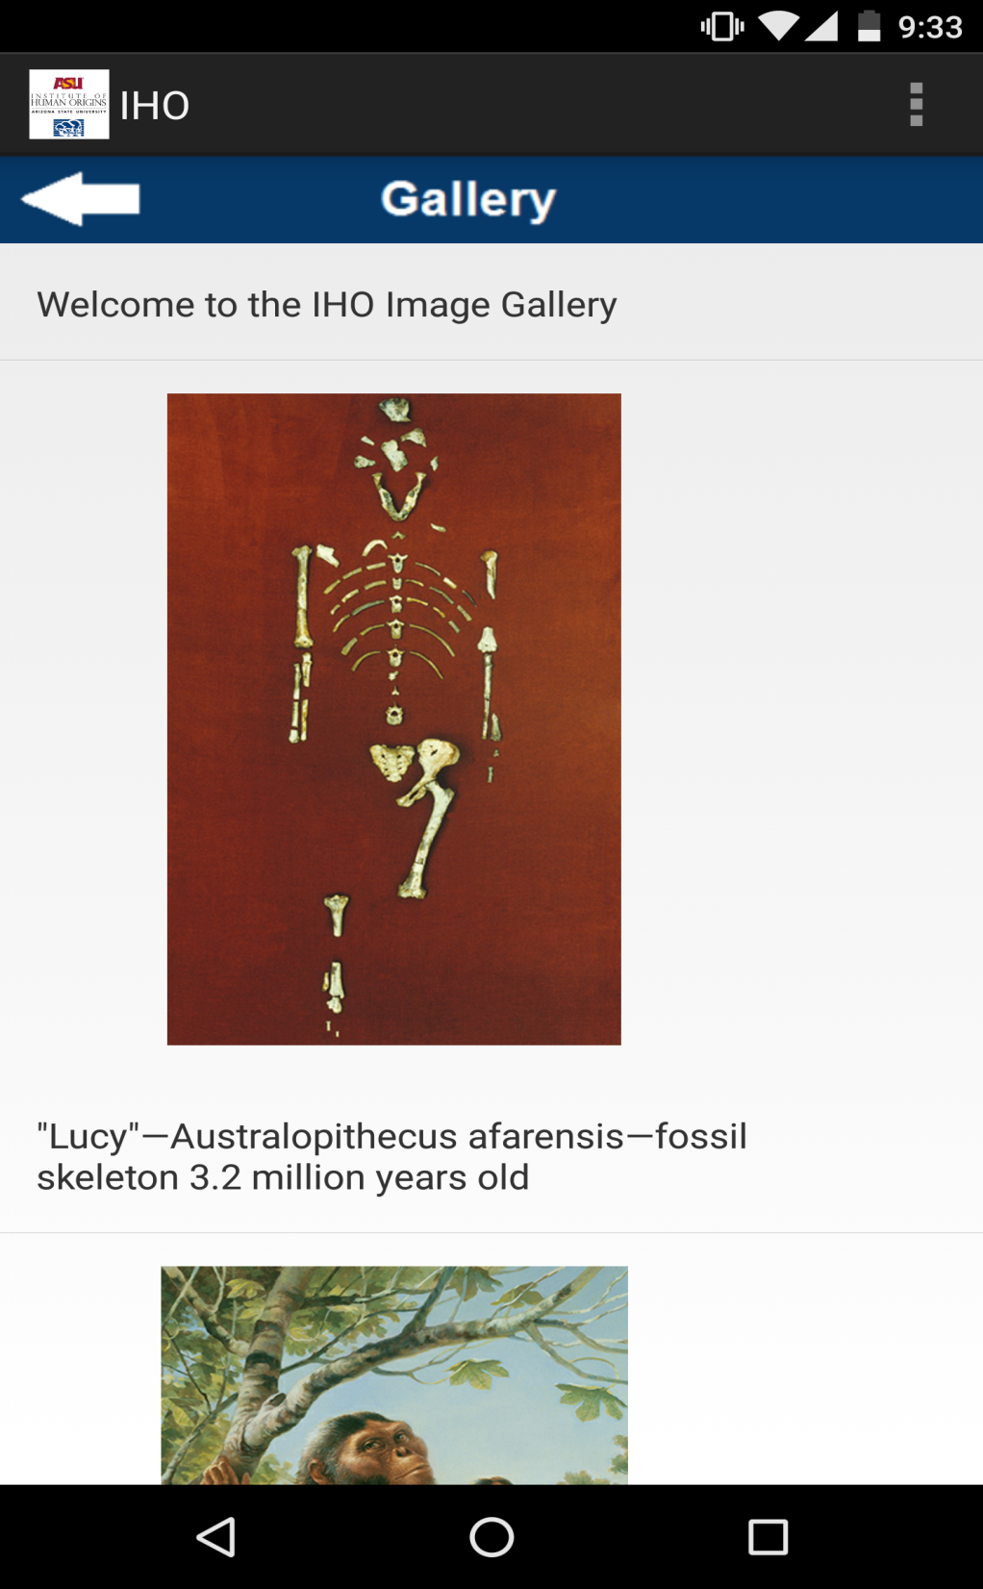

*Figure 18:This screen comes up when user clicks on “Gallery” button from Application’s home page. Earlier, clicking of gallery caused the application to shut down, because it was throwing Database Exceptions. Now, as database exceptions are removed and handled, this section now connects to the Gallery table in the database and to show pictures.*

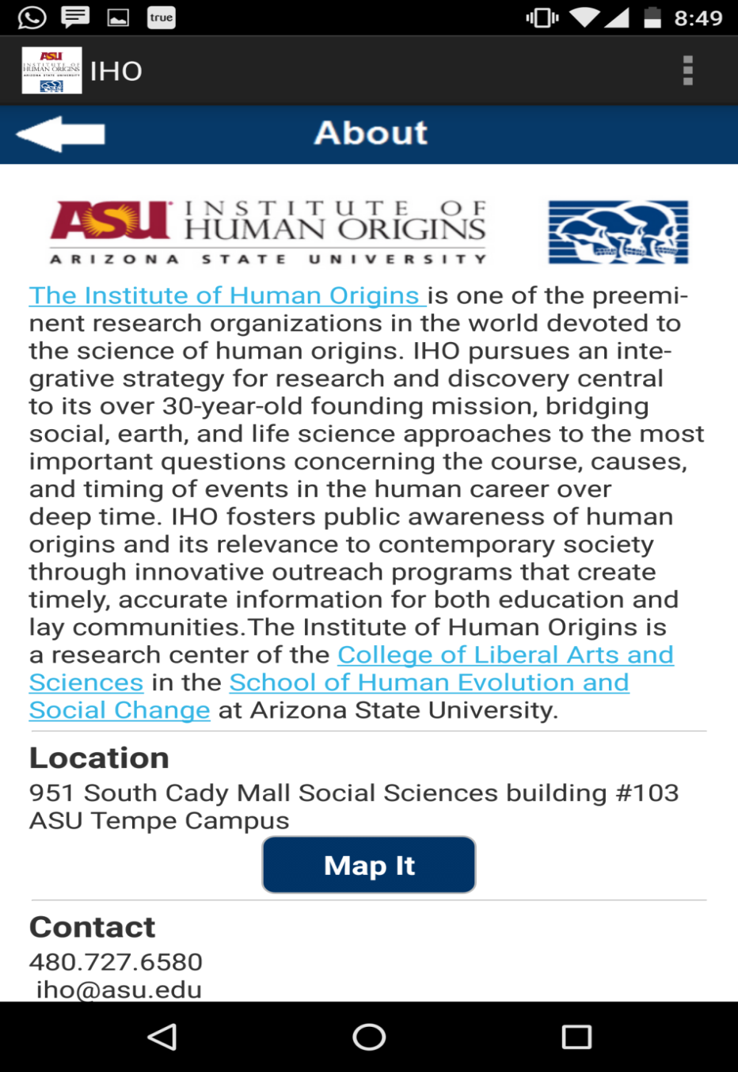

*Figure 19:This screen comes up when the user clicks on “About” button from the home page. It will display general information about ASU’s IHO Department, along with contact and location mapped on Google Maps.*